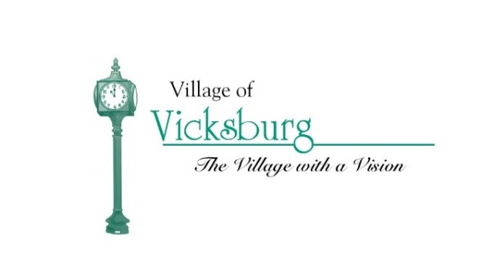
Parks & Recreation Committee Meeting Agenda
Thursday, October 12, 2017 @ 7:30 p.m.
Vicksburg Community Center – Merritt Harper Room – Frist Floor

- Call to Order – Jim Earl
- Roll Call – Don Wiertella
- Approval of Agenda – Jim Earl
- Approval of meeting minutes – Jim Earl
  - Approve minutes from August 10, 2017, Meeting

- Review of Parks and Recreation FY 17 -18 Budget – Jim Earl
- Funding for capital improvements for village parks – Jim Earl
  - Work completed in FY 17 – 18
  - Work TO BE completed in FY 17 – 18
  - Garbage Bin Storage Unit – Don
    - Thursday Guys will fabricate for Historic Village

- Public Comments

- Member Comments

- Next Meeting

- Adjournment

