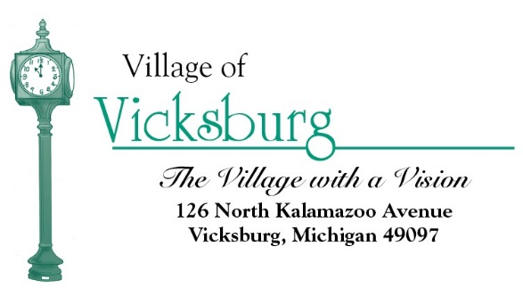
Village of Vicksburg
Municipal Building Authority
126 N. Kalamazoo Avenue, Vicksburg, MI
Monday, September 25, 2017
8:00 a.m.

Agenda

- Call to Order

- Roll Call

- Approval of Agenda

- Approval of Minutes May 26, 2016

- Consider Approval of 2017 Meeting Dates

- Adjourn

