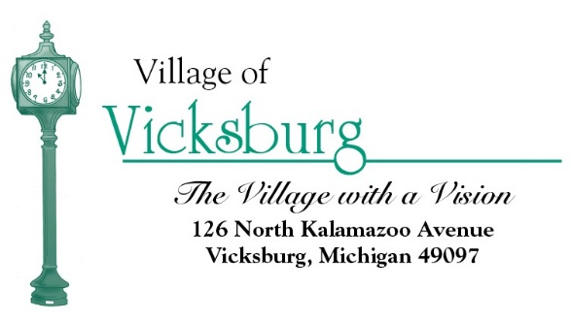
Village of Vicksburg
Municipal Building Authority
Yogi’s
2070 E VW Avenue, Vicksburg, MI
Monday, January 30, 2017
8:00 a.m.

Agenda

- Call to Order

- Roll Call

- Approval of Agenda

- Approval of Minutes May 26, 2016

- Consider Approval of 2017 Meeting Dates

- Adjourn

