Curbside Trash Collection

The Village of Vicksburg will be providing
a residential curbside trash collection
again this year! Collection will be
Saturday, May 18, 2019. Services will be provided by Best Way Disposal. Items should be placed curbside no earlier than Wednesday, May 15th. You are responsible for making sure trash stays orderly throughout the time on curbside to avoid being cited.
There will be no callbacks.

- It is becoming increasingly difficult to find trash haulers who offer curbside collection; please follow these guidelines to help the haulers. All items must not be over four feet (4’) in length.

The following items WILL be picked up:

- Furniture – mattresses, box springs, sofas, tables, etc. Toys, bicycles, home fixtures. Items must be less than 4 feet in length. Mattresses and box springs must be bagged.

- Trash – must be bagged or boxed to allow for handling by two persons. Bags and containers must weigh less than 50 lbs

- Metals – must be kept separate from all other trash

- Canned items – tar, driveway sealer, Latex Paints (contents must be dry and lids removed)

- Wood – Small amounts from non-construction projects

The following items WILL NOT be picked up:

- White goods –stoves, refrigerators, dishwashers, hot water heaters, etc.

- Construction debris

- Brush & yard trimmings-including leaves and grass (See back of flyer for additional information on pick-up)

- Household garbage or any container containing food products

- Rocks, sand or concrete rubble

- Dead animals and pet wastes

- Household hazardous wastes-including oil based paints, liquid latex paints, gasoline, motor oil, solvents, pesticides, etc

- Liquid waste or hazardous waste, any type of batteries

- Car parts (engines, batteries, tires, rims, etc.) or heavy iron, large plastic drums.

- Major building materials generated from commercial projects

- No propane cylinders

- Rubber tires

- Carbonated beverage containers (i.e. soda/beer cans)
LEAVES AND BRUSH PICK UP
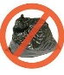
- Leaves must be placed in ‘paper’
bags NOT PLASTIC!

- Loose leaves will not be collected

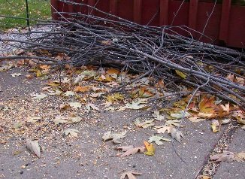
- Brush must be laid in piles with cut
ends in same direction

- Scattered piles will not be collected

Crews from the DPW will make daily rounds through the Village to collect leaves and brush that are properly prepared.

Additional information may be obtained thru our office at 269-649-1919.

