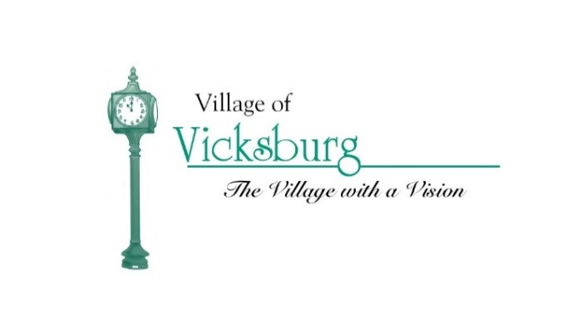
Parks & Recreation Committee Meeting Agenda
Thursday, April 12, 2018 @ 7:30 p.m.
Vicksburg Community Center – Merritt Harper Room – Frist Floor

- Call to Order – Ron Smith
- Roll Call – Don Wiertella
- Approval of Agenda – Ron Smith
- Approval of meeting minutes – Ron Smith
  - Approve minutes from March 8, 2018

- Welcome Sandy DeVito as new member
- Funding for capital improvements for village parks – Ron Smith
  - Work completed in FY 17 – 18
  - Work TO BE completed in FY 17 – 18
  - Work requested for FY 18 – 19 (needs – wants – wishes)
  - Work potential for FY 19 – 20 (needs – wants – wishes)

- Public Comments

- Member Comments

- Next Meeting

- Adjournment

